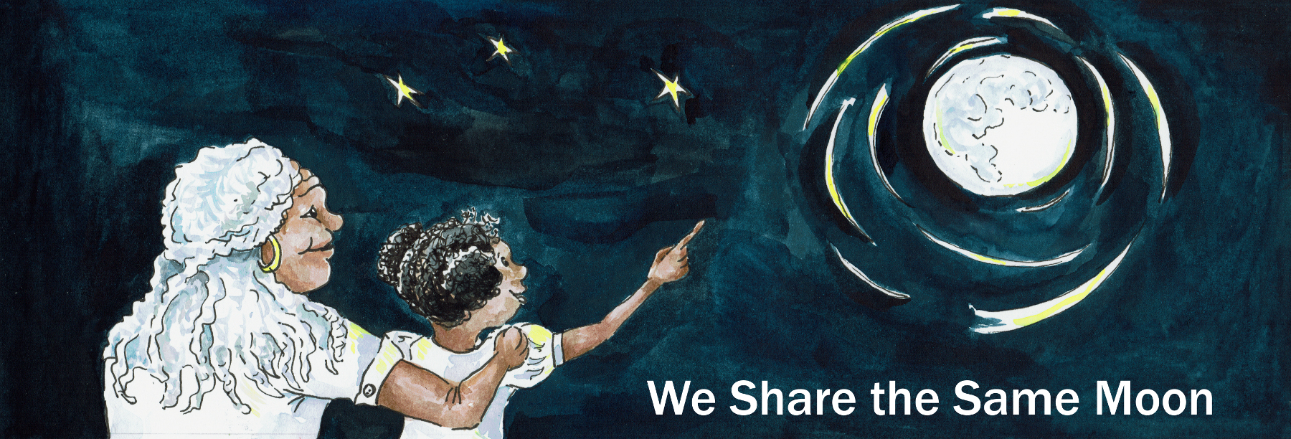
Suggested Age Range: 4 - 5 years; 5 - 6 years; 6 - 7 years; 7 - 8 years
UK Curriculum: Key Stage One
Suggested UK Year Group: Year Two
UK Primary Curriculum Link: Living Things and Their Habitats
Science Subject: Plants
Science Questions: What would people from the Moon discover when they reached planet Earth?
Suggested Science Activity: Balloon rockets
Children with SEND: Use to boost comprehension of vocabulary through repetition, rhythm and rhyme
EAL children: Beginners Level
Country of Origin: The Caribbean islands
Source: Unknown (heard in a performance 30 years ago)

Long ago, when the world began, according to Caribbean legend, the very first people did not live on the planet Earth - No, no, no, no! No, no, no, no! No, no, no, no!

They lived far away on the Moon - Yes, yes, yes, yes! Yes, yes, yes, yes! Yes, yes, yes, yes!

And they kept the Moon sparkling, shining, shimmering, silvery clean!

Every day they would down get on their hands and knees and take their cloths and they would:
Clean, clean, clean, clean.
Clean, clean, clean, clean.
Clean, clean, clean, clean.
Clean, clean, clean, clean.

Every day they would take their brushes and they would:
Brush, brush, brush, brush.
Brush, brush, brush, brush.
Brush, brush, brush, brush.
Brush, brush, brush, brush.

Every day they would take their mops and they would:
Mop, mop, mop, mop.
Mop, mop, mop, mop.
Mop, mop, mop, mop.
Mop, mop, mop, mop.

Until their planet was sparkling, shining, shimmering, silvery clean!
They were so proud of their clean Moon!

But …
One night, a young girl was standing on the Moon, as she always did.
She looked down and saw how clean the Moon was, as she always did.

But, then she looked up into the sky and saw something she had never seen before.
She saw something hanging in the sky … A great brown blob! Going ‘blup!”
Ugh! What was it? Ugh - it looked so dirty!

The young girl asked her mother:
“What is that great brown blob up there in the sky going “blup?"
And her mother did not know.

So she asked her father”
“What is that great brown blob up there in the sky going “blup?" But he did not know.

She asked everybody until finally she came to the oldest person on the Moon, her great, great, great, great Grandmother.

“Please great, great, great great Grandmother, do you know what is that great brown blob up there in the sky going “blup?”

“It is a planet, the planet Earth” said great, great, great great Grandmother.
“But why is it so dirty?” asked the young girl.
“Because there is nobody living on the Planet Earth to clean it up”.

“Well!” thought the young girl, “That’s not right”
So she gathered together.all the Caribbean people and said:
“We should go, we should go, we should go and clean it up!”
And they all agreed.“We will go, we will go, we will go and clean it up!”

But how could they travel to the planet Earth?
Great, great, great, great Grandmother said: “We travel around our Moon by canoe so let us build an enormous canoe and paddle to the planet Earth.”

So, they chopped down an enormous tree - chop, chop, chop, chop.
They carved it into the shape of a canoe - carve, carve, carve, carve.
They each sawed off a branch - saw, saw, saw, saw, to make a paddle.
And then they climbed into their canoe and they began to paddle and paddle and paddle, faster and faster and faster and faster until the canoe …
Whoosh! It flew! Wheeeee! All the way to the planet Earth!

And then the canoe came down from the sky to land … SQUELCH!
Onto the sticky, smelly, slippery brown mud that covered the planet Earth.
Everything was covered in mud! The sea, the mountains, the trees, the flowers even the animals, all of them were covered in mud!
Oh dear! BUT the Caribbean people did not give up!
They climbed out of their canoe and began to clean!

They took their cloths and they:
Cleaned, cleaned, cleaned, cleaned.
Cleaned, cleaned, cleaned, cleaned.
Cleaned, cleaned, cleaned, cleaned.
Cleaned, cleaned, cleaned, cleaned.

They took their brushes and they:
Brushed, brushed, brushed, brushed.
Brushed, brushed, brushed, brushed.
Brushed, brushed, brushed, brushed.
Brushed, brushed, brushed, brushed.

And then they took their mops and they:
Mopped, mopped, mopped, mopped.
Mopped, mopped, mopped, mopped.
Mopped, mopped, mopped, mopped.
Mopped, mopped, mopped, mopped.

Until everything was clean! Glistening, glimmering, glittering clean!

And the Caribbean people, once they saw how beautiful the planet Earth could be, they decided to stay on the planet Earth and keep it clean forever. And so they did.
And that is how the Caribbean people discovered the planet Earth and cleaned it up!

But … is this true?

Did the very first people live on the Moon? Can people live on the Moon?
Scientists say that it is not possible to live on the Moon.
Because … there is no air, or water or soil for plants and people to live.
But … what do YOU think is true?

Copyright Cassandra Wye May 2019

